**User’s Guide**

*to the Živa Nada church website*

1. **Introduction:**

This website is intended to serve as an informational website for both the members of the Živa Nada church body, as well as potential guests considering visiting the church. For potential guests, this serves as a place to find out more about the values of the church, information about members serving in the church, and also information about the location such as address, parking lots, and navigation from parking lots. For members of the Živa Nada church body, the main value provided will be the “Događaji” (Events) section, detailing information about upcoming events the church is hosting. Additionally however, it will also be useful for those who already attend the church to see information such as church values they may not have known about, or even information about the staff they might not have heard. To visit the website, simply go to: [www.ks-zivanada.hr](http://www.ks-zivanada.hr)

1. **Usage**
   1. ***Guest Usage:***

When first arriving at the website homepage you will be greeted with five navigation options in the navigation bar, as well as one additional option below the church name, as seen below: 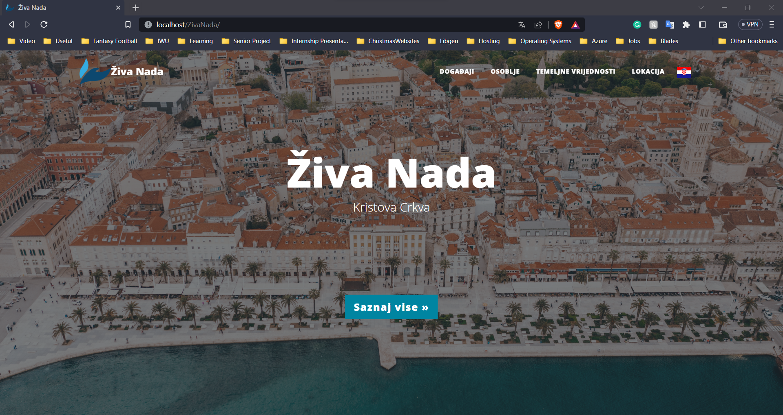

**6**

**5**

**4**

**3**

**2**

**1**

Figure 1: Homepage

* + 1. ***“Događaji” (Events):***

The first option will take you to the events page where you can look through all the upcoming events that have been posted. They are sorted by date, with the furthest event away being listed at the top.

* + 1. ***“Osoblje” (Staff):***

The second option will take you to a page showing information about many of the members that are currently serving in the church, such as pastors, worship leaders, men’s and women’s group leaders, etc. Each and every one of these individuals would love to get to know you more and answer any questions if you have any, so don’t hesitate to pull them aside if you see them!

* + 1. ***“Temeljne Vrijednosti” (Core Values):***

This section goes through some of the most important information the site has to offer. Each and every one of these values listed has been carefully thought through and prayed over, and they truly speak to what the church believes in. If you are considering coming here more often, this may be something you would like to examine carefully to ensure you understand them, and if you don’t, feel free to reach out to pastor Zdenko!

* + 1. ***“Lokacija” (Location):***

Here is where you will find any information you could need regarding location. We have set up a convenient map of the area, in which you will find a pin for each of the main parking locations. As seen below, if you click on any of the parking location pins, you will be given instructions on the best way to walk from your parking location to the building. If you would rather use Google Maps, there is also a link to each of the routes included underneath the instructions.

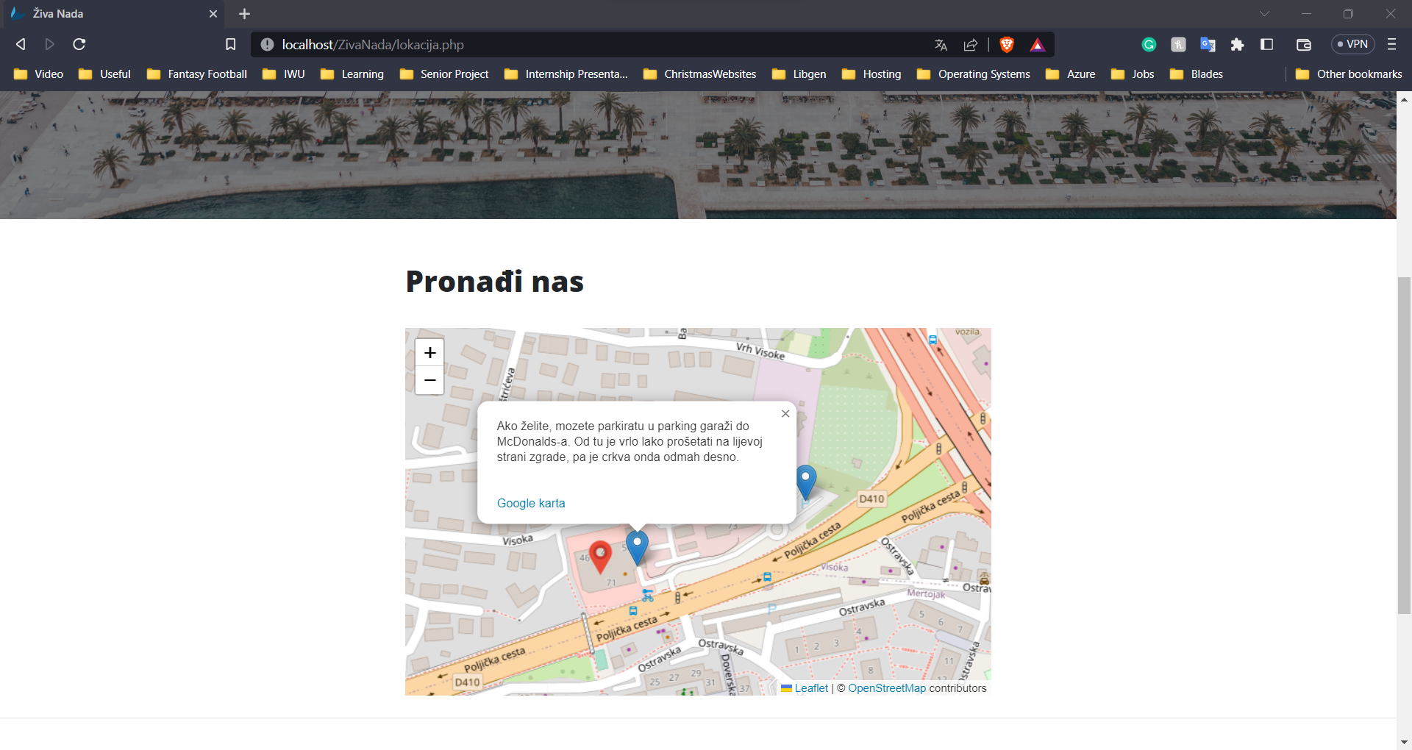

Figure : Parking Information

* + 1. ***“Jezik” (Language):***

For the guest user that may not understand Croatian, such as a tourist visiting the area, by clicking the flag icon one can easily switch the website to English rather than Croatian. An important thing to note is that the “Events” section will only exist on the Croatian version of the website.

* + 1. ***“Saznaj više” (Learn more):***

This button simply is another way of taking you to the “Core Values” section of the website, as if you want to really know who we are, that section does the best job of introducing us.

* 1. **Admin Usage**
     1. ***Registration:***

First of all, navigate to the website footer and find the link that says “Admin prijava” (Figure 3). That will lead you to the login and registration page listed below (Figure 4). To register, simply enter your name, last name, email, and password of your choice and click the button with the words “Registriraj se” (Figure 5). Then contact one of the other admins of the site, and as long as you were assigned to become a site administrator your permissions will get updated by one of them.



Figure 3: Footer with Admin login link

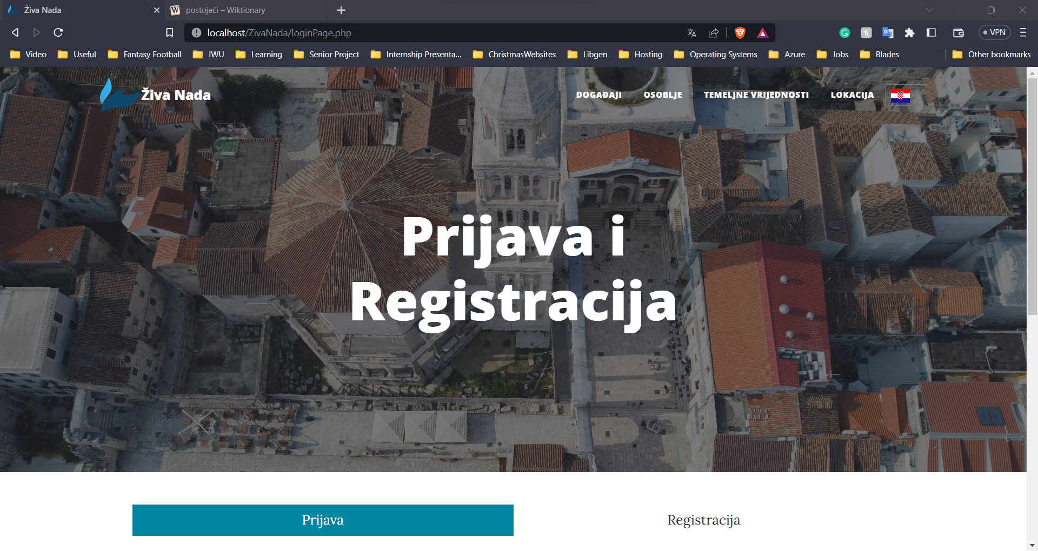

Figure : Login and registration page

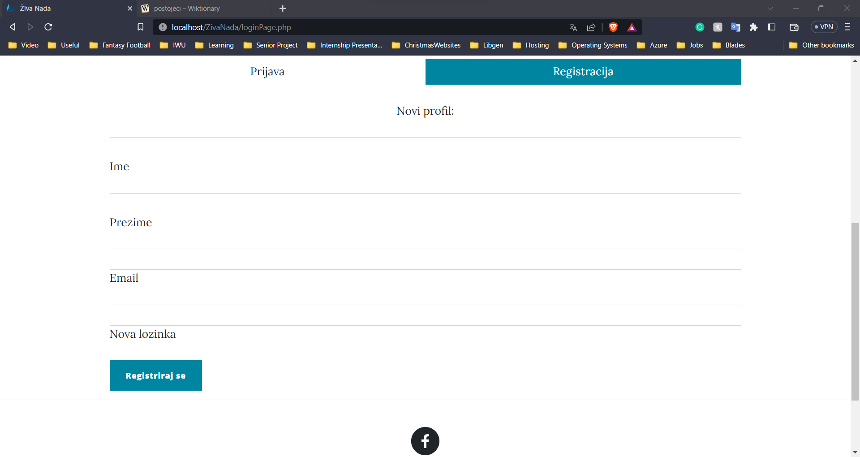

Figure : Registration confirmation button

* + 1. **Login:**

Once you have been accepted as an admin, you will be able to login by clicking on the “Prijava” option from the top of the image above (Figure 5). That will take you to this screen below where you will be able to insert your email and password to access administrative tools on the website. If you have forgotten your password, simply click the text that says “Zaboravili lozinku?” (Figure 6).

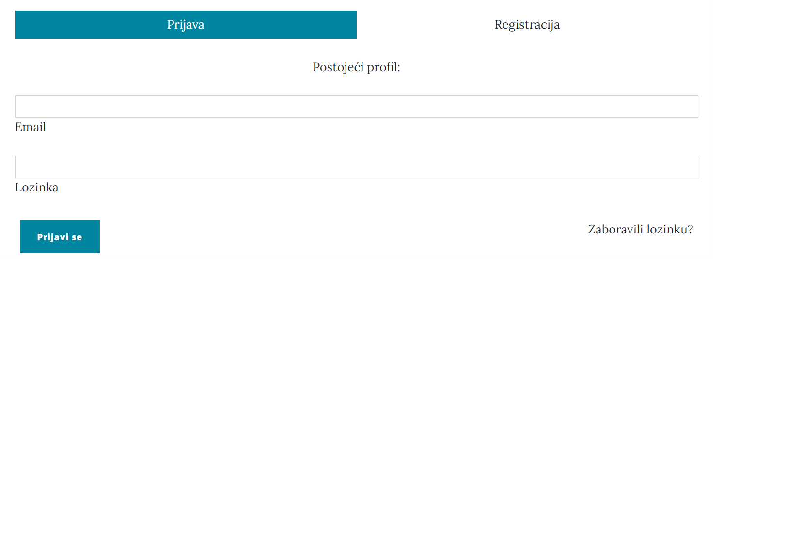

Figure 6: Forgot password button

This will bring up a text box in which you will enter the email address that you used to sign up (Figure 7). Once you submit your email, you should receive a message with a hyperlink that will take you to the password reset page.

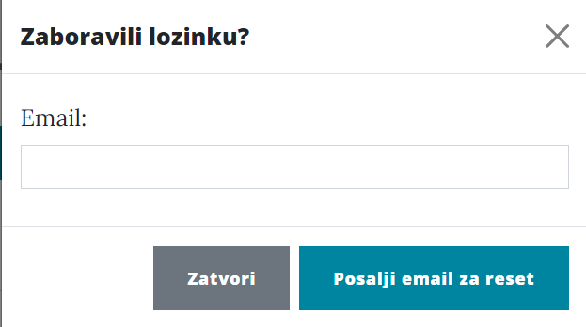

Figure : Password reset text box

* + 1. **Posting Events**

Once you have been accepted as an admin and have logged in, you will be able to navigate to the “Događaji” page to post events that may be going on. If you are logged in, you should see a button that says “Nova Objava” (Figure 8). This will bring up an input box where you will be able to input the title, date, time, and description of the event (Figure 9). Once you hit the button that says “Objavi” you are done!

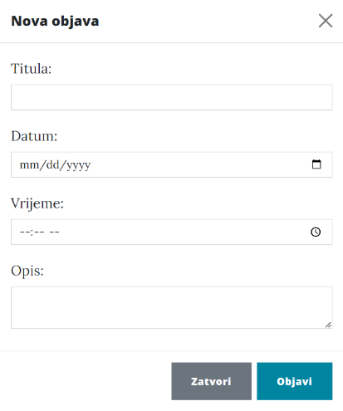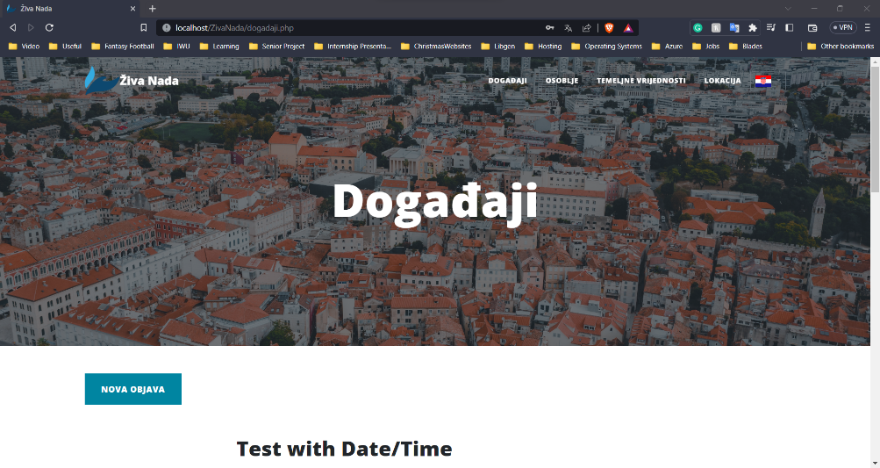

Figure 9: Post input box

Figure : New post button

* + 1. **Editing Events**

If you have posted an event, but you realize that you need to change something in either the title, description, date or time, you can easily do so by clicking the blue edit button shown in the image below (Figure 10). That will bring up a similar input box as the one you saw before in which you will be able to simply edit the information you put in and then hit “Objavi” (Figure 11).

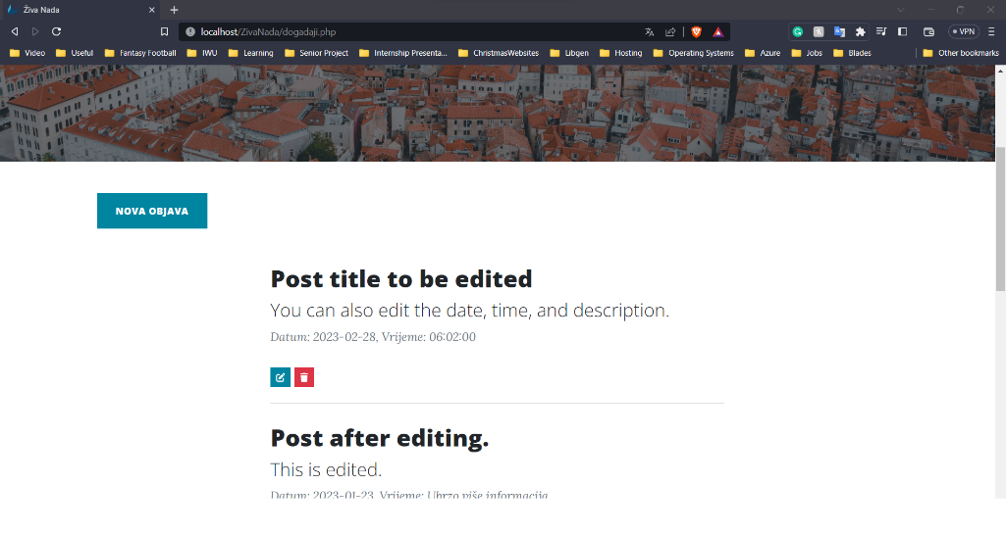

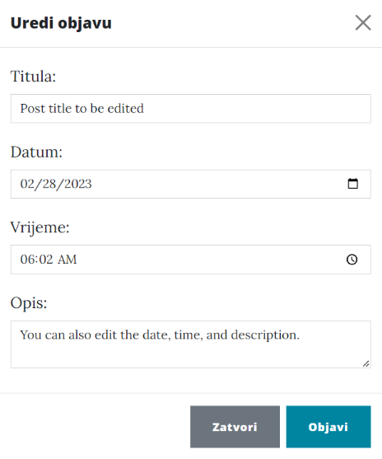

Figure 11: Edit post input box

Figure 10: Edit and delete buttons

* + 1. **Deleting Events**

If an event happens to get cancelled, you can easily delete the event by clicking the red delete button in the image above (Figure 10). This will bring up a box asking you if you are sure you want to delete the event. If you are sure, click “Potvrdi” (Figure 12). **Caution:** this action is irreversible. If you decide you shouldn’t have deleted the event you will have to repost the event from the beginning.

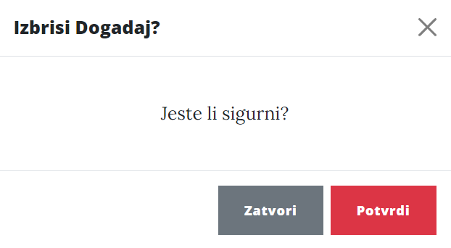

Figure 12: Deletion confirmation box

* + 1. **Logging Out**

Once you are finished posting, editing, or deleting, you can easily logout by clicking on the “Profil” link in the footer where the “Admin login” link would be if you weren’t logged in. Once you are there you can simply click “Odjava” to log yourself out (Figure 13).

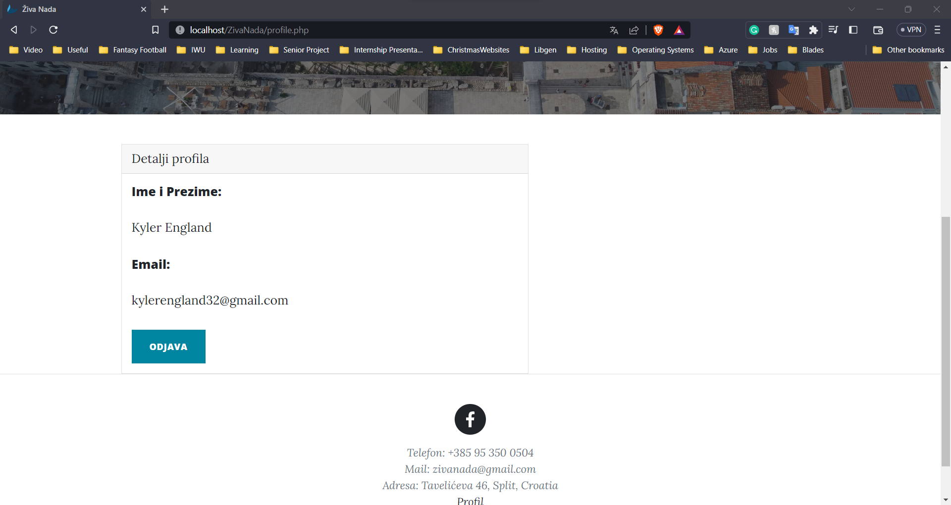

Figure : Logout button

1. **Conclusion**

While this website includes many options for both guests and members, do note that it is still in progress. If you find something that you find is not working as intended, or if you have more features you would like to see added, please do not hesitate to reach out to Pastor Zdenko, and we will get it figured out!